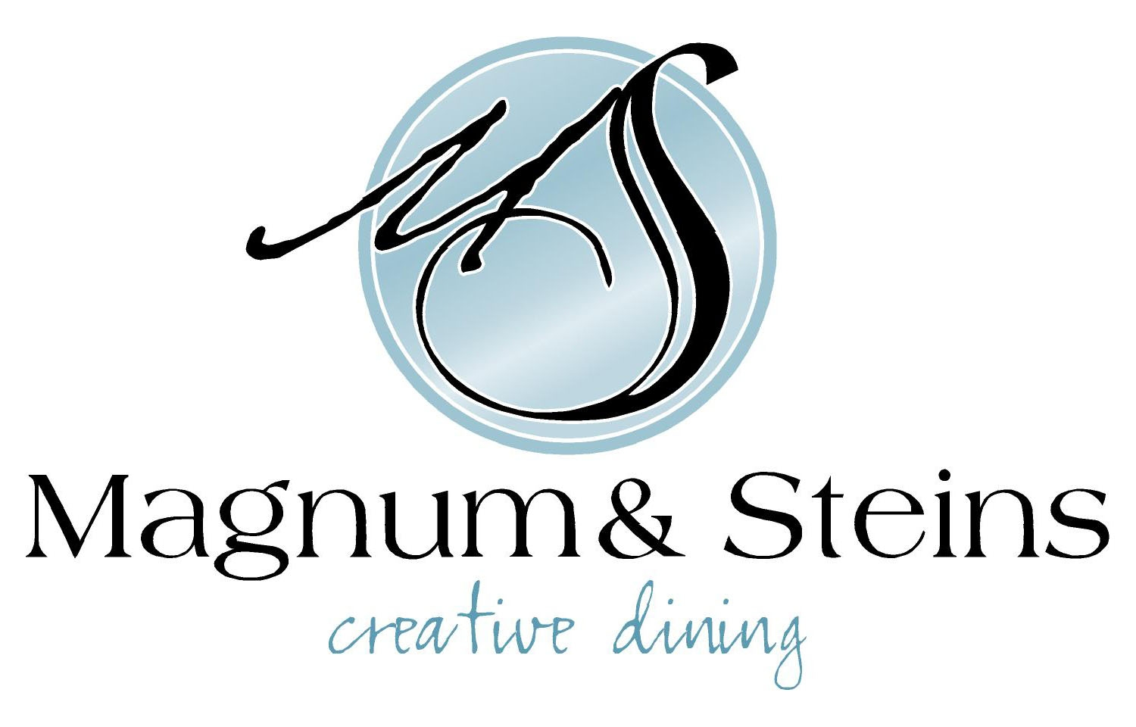

Orange & Butternut Squash Soup

$12

Caesar Salad

Romaine Hearts | Double Smoked Bacon Lardons | Parmesan | Crostini

$12

Phyllo Wrapped Brie

Apples & Leeks | Red Wine & Grape Sauce

$14.50

~~~~~~~~~~

Chicken

Oven Roasted Chicken Breast | Root Vegetable Fricasse | Blueberry Dumpling

$28

AAA Beef Tenderloin
Whipped Potato | Vegetable Jardinaire |Crispy Fried Onions | Bacon Jam | Demi Glace
$45

Blackened Salmon

Risotto Verde | Sauteed Julienne Vegetables | Sundried Tomato Hollandaise Sauce

$34

Braised Lamb Shank

Smoked Cheddar Mashed Potato | Mirepoix | Braising Jus

$27 1Pc $37 2Pc

~~~~~~~~~

Chocolate Peanut Butter Phyllo

Warmed Spiced Cake

Tetley Tea Crème Brulee

$12.50

Vegan/Vegetarian Options Available Upon Request

