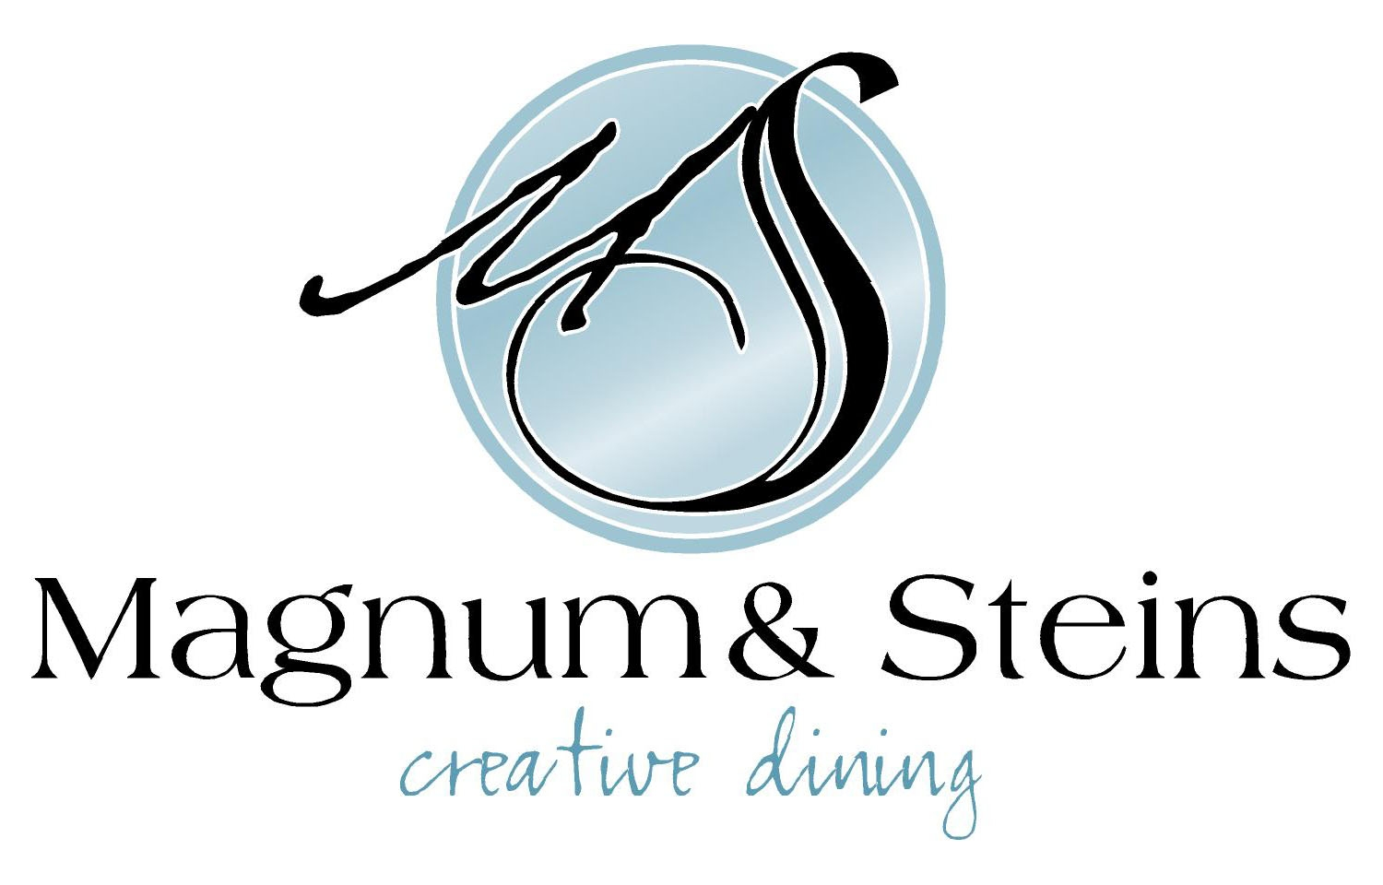

Tomato & Gin Soup

Tomato| Gin | Sour Cream | Crostini

or

Caesar Salad

Romaine Hearts | Double Smoked Bacon Lardons | Parmesan | Croutons

or

Duck Nacho

Fried Wontons | Carrot & Ginger Slaw | Sweet & Spicy Sesame Soy | Duck Confit

~~~~~~~~~~

Chicken

Roasted Chicken Breast | Baby Potato | Wilted Spinach | Tomato | Mushroom Marsala Sauce

or

Salmon

Pan Seared Salmon | Potato Gnocchi | Julienne Vegetables | Lemon & Caper Dill Butter

or

Lamb Shank

Braised Lamb Shank | Mashed Potato | Mirepoix | Braising Jus

or

Pasta

Classic Beef Bolognese Sauce | Parmesan Cheese

~~~~~~~~~

Bread Pudding

Warmed Ginger & Cranberry Bread Pudding

or

Torte

Flourless Chocolate Torte with Berry Coulis

or

Crème Brûlée

Tetley Tea Flavoured Crème Brûlée

$55 plus taxes & gratuity.

Vegan & Vegetarian Dishes available upon Request

